

**Web Application & Internet Project Proposal:**

**COFFEE CAFÉ MONITORING SYSTEM**

**Report-1**

|  |  |
| --- | --- |
| **Name** | **ID** |
| Shahriar Mahmud Anik | 1830872 |
| Sharmin Islam Shroddha | 1822217 |

**Contents**

**1. Background of the Project 3**

**2. Objective of this project 3**

**3. Proposed system with rich picture 3**

**4. System Functions 4**

**5. User Characteristics 4**

**6. Functional Requirement 4**

**7. Advantage 6**

**8. Conclusion 7**

**Background of the Project**

A coffeehouse, coffee shop, or cafe is an establishment that primarily serves coffee of various types, e.g. espresso, latte, and cappuccino. Some coffeehouses may serve cold drinks, such as iced coffee, iced tea, and other non-caffeinated beverages. A coffeehouse may also serve food, such as light snacks, sandwiches, muffins, fruit, or pastries. This project is about online coffee shop website where customer can know about the coffee shop. This would be beneficial for both the customers it is targeted towards and also the project stakeholders.

**Objective of this project**

Our project is completely concern about making a system which surely monitors the impact of policies against overall administrative goals. For adding any food menu, the system would be able to store individual food details in the database of the system to view the recent able-able items in the café. The customer can look over the food items with its price to satisfied their query about the café.

**Proposed system with rich picture**

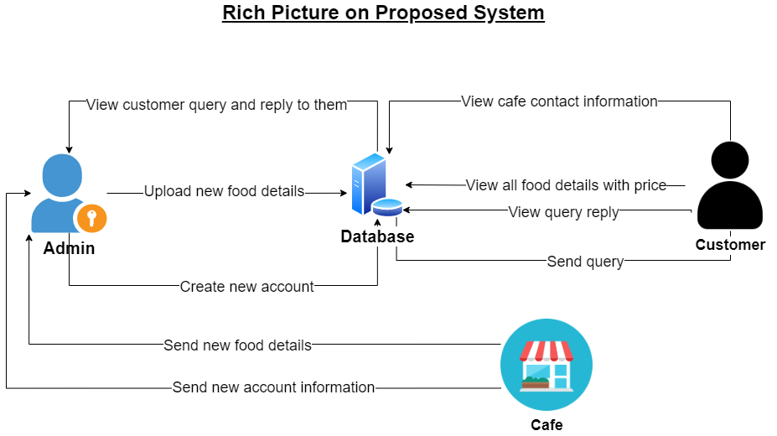

Fig 1: Rich Picture

**System Functions**

Coffee Café will have primarily two user types – Customer and Admin. who will be managing and updating the system as required. Given below are the product functions for each user.

Customer

* View about the Coffee café
* View menu of Coffee café with price
* View contacts of Coffee café
* Send Customer query
* View query reply from the coffee cafe

Admin

* View customer query and reply to them
* Upload new food item details in a specific category
* Create new account

**User Characteristics**

Users of the software system include admin and customer. All users are assumed to have a basic understanding of computers and internet browsing. Administrators of the system should have more knowledge of internal modules of the system.

**Functional Requirements**

1. **Name of function:** View about the Coffee cafe

|  |  |  |
| --- | --- | --- |
| **Actor:**Customer | **Process:**   * Open the coffee café website. * Click “About Cafe” button from the navigation bar. | **Output:**   * Show coffee café information. |

1. **Name of function:** View menu of Coffee café with price

|  |  |  |
| --- | --- | --- |
| **Actor:**Customer | **Process:**   * Open the coffee café website. * Select “Food”/ “Beverages”/ “Combo Offers” from a drop down list which is menu. * Again select a category what kind of food you prefer to view. | **Output:**   * Show menu of the coffee café. |

1. **Name of function:** View contacts of Coffee café

|  |  |  |
| --- | --- | --- |
| **Actor:**Customer | **Process:**   * Open the coffee café website. * Click “Contacts” button from the navigation bar. | **Output:**   * Show coffee café contact information. |

1. **Name of function:** Send Customer query

|  |  |  |
| --- | --- | --- |
| **Actor:**Customer | **Process:**   * Open the coffee café website. * Click “Customer Query” button from the navigation bar. * Enter Customer name, email, query. * Chick “Send” button. | **Output:**   * Show a confirmation message for the sent query. |

1. **Name of function:** View query reply from the coffee café.

|  |  |  |
| --- | --- | --- |
| **Actor:**Customer | **Process:**   * Open the coffee café website. * Click “Customer Query” button. | **Output:**   * Show customer query reply from the coffee café. |

1. **Name of function:** View customer query and reply to them.

|  |  |  |
| --- | --- | --- |
| **Actor:**Admin | **Process:**   * Open the coffee café website. * Click “Customer Query” button. * Write a reply into the reply text box. * Click “Send” button. | **Output:**   * Show a confirmation message for the sent query reply. |

1. **Name of function:** Upload new food item details in a specific category.

|  |  |  |
| --- | --- | --- |
| **Actor:** Admin | **Process:**   * Open the coffee café website. * Click “Admin” button. * For Log in as Admin into the system enter id, password and click the “Log in” button. * After log in successfully, select a food category. * Fill up all the field according to the new food information. * Again click “Send” button. | **Output:**   * Show a confirmation message for create a new food instance. |

1. **Name of function:** Create new account

|  |  |  |
| --- | --- | --- |
| **Actor:**Admin | **Process:**   * Open the coffee café website. * Click “Admin” button. * For Log in as Admin into the system enter id, password and click the “Log in” button. * After log in successfully, click on “Create a new account”. * Enter name, email, password, phone number. * Click “Create Account” button. | **Output:**   * Show a confirmation message for create a new account. |

**Advantage**

The advantages of Coffee Café System cannot be explained but could be summarized. The world has seen an extraordinary growth in technology in the past few decades than in centuries; with necessity in cloud computing and data management, many organizations have opened their gates to simplify procedures by reducing human effort. Customers can have an idea before visit the coffee café. They can view the new items of the coffee café with the price. The website will view more information about the coffee café so that customer can know why coffee café is special and why they should visit coffee café.

**Conclusion**

The project's goal is to automate manual tasks and existing structures in order to boost the program's overall efficiency. The incorporation of the newly offered features has the potential to improve the overall system's capability. The goal of the project is to improve the system as much as possible while maintaining a reasonable level of efficiency.

Appendix:

* Admin
* Customer